Name: Mifrah anis

Practice Questions

1. 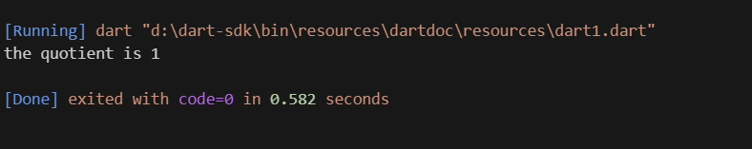Write a Dart program that calculates the result of integer division between two numbers and prints the quotient.

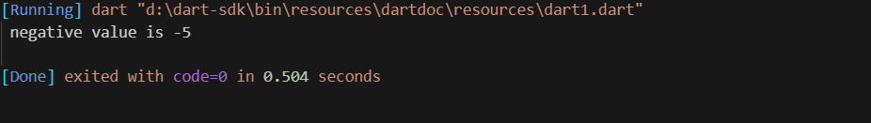2) Write a Dart program that takes an integer as input (initialize) and prints its negative value using the unary minus operator.

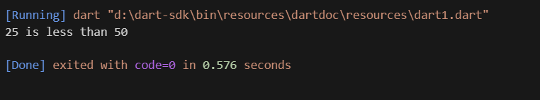3) Write a Dart program that compares two numbers and prints whether the first number is less than or equal to the second.

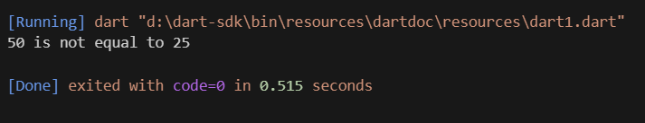4) Write a Dart program that compares two numbers and prints whether they are equal.

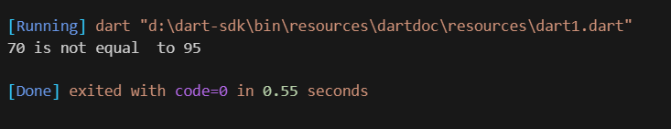5) Write a Dart program that compares two numbers and prints whether they are not equal

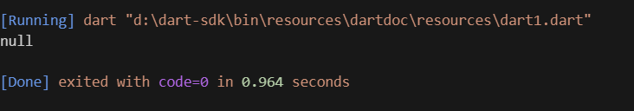6) Write a Dart program that initializes a variable with a default value and updates it only if the variable is null

7) Write a Dart program that checks if a person is eligible to vote based on their age and citizenship. The person must be at least 18 years old and a citizen.

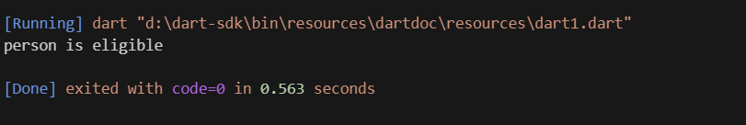

8)Write a Dart program that checks if a user is eligible for a discount on a purchase. The discount is applicable if the user is a premium member or if their total purchase amount exceeds $100.

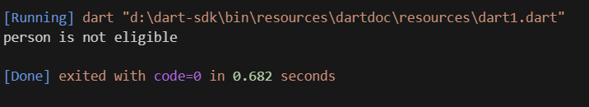

9) Write a Dart program that checks if a user has not subscribed to a newsletter. The user will receive a promotional offer only if they are not subscribed.

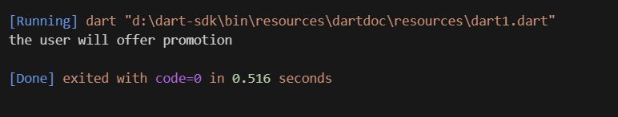

10) Write a Dart program that determines whether a given number is positive or negative using the ternary operator

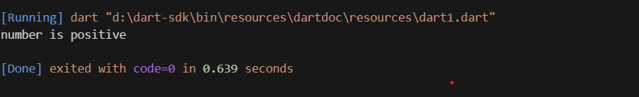

11) Write a Dart program that determines whether a given number is even or odd using the ternary operator.

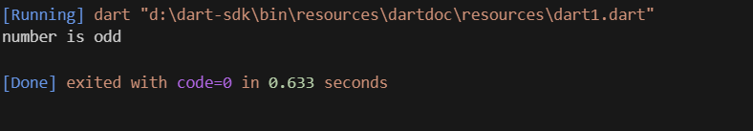

12) Write a Dart program that checks if a person is eligible to vote based on their age, using the ternary operator.

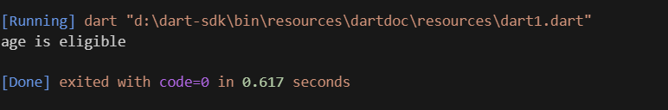

13) Write a Dart program that checks if a user is eligible for a discount on a purchase, using the ternary operator.

